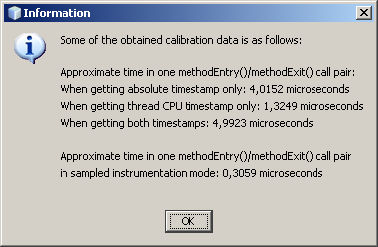
INFO de.uka.ipd.sdq.ByCounter.utils.MessageDigestBenchmarker.makeInitialMeasurements.83 2008-03-13 10:35:13,062 573266
7236674 ns for MD creation (incl. nanoTime())
INFO de.uka.ipd.sdq.ByCounter.utils.MessageDigestBenchmarker.makeInitialMeasurements.84 2008-03-13 10:35:13,062 573266
5751102724 ns for 5 MD updates (incl. nanoTime())
INFO de.uka.ipd.sdq.ByCounter.utils.MessageDigestBenchmarker.makeInitialMeasurements.85 2008-03-13 10:35:13,062 573266
1150220544 ns for MD update (incl. nanoTime() share)
INFO de.uka.ipd.sdq.ByCounter.utils.MessageDigestBenchmarker.makeInitialMeasurements.86 2008-03-13 10:35:13,078 573282
198628 ns for MD digest (incl. NanoTime())

private Logger log;

public MathBenchmarker(){
PropertyConfigurator.configure("log4j.properties");
log = Logger.getLogger(MathBenchmarker.class);

